WQD7001 PRINCIPLES OF DATA SCIENCE
Group Assignment (GA- 40 %)
This assignment is divided into 2 parts (GA1 and GA2)
Data science is the domain of study that deals with vast volumes of data using modern tools and techniques to find unseen patterns, derive meaningful information, and make business decisions. The first task of data scientist is to understand the objectives and requirements of the project. It is important to determine business objectives and define business success criteria. In other words, what should the project try to achieve? The following diagram shows a typical data science process life cycle (DSPLC).
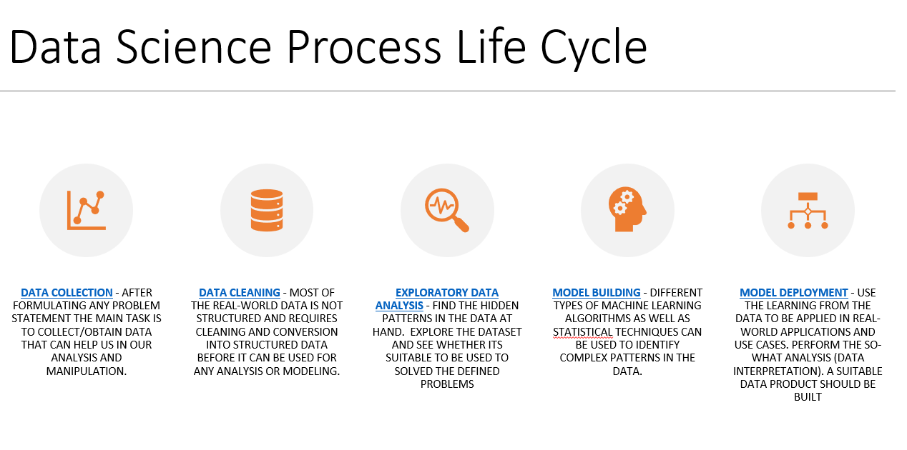
GA1
GA2
As a data scientist , you may do the following tasks : i) Discover patterns and trends in datasets to get insights; ii) Create forecasting algorithms and data models.; iii) Improve the quality of data or product offerings by utilising suitable DS tools and machine learning techniques and finally become the top in field of data science innovations.
The domain areas would be the one under Sustainable Development Goals (SDG)



This proposal will lead to the development of a model and a data product. You may choose a case study (scenario) from your reading, or actual scenario or event based on your working experience before you come out with your proposal. A case study will also help you to write your problem statement clearly, as case study discusses about problems faced by a business. In addition, a case study will help you to identify why a business needs to analyze the dataset, and gain insight from it.

This objective of this project is to give an opportunity for students to:

1. Apply the whole data science processes into one complete Data Science project.
2. Show an understanding of real problems that can be solved using data science.
3. Apply Analytical thinking of a Data Scientist to improve the data science workflow.
4. Showcase your solution – the ‘data product’ and work together as a team

Team Formation:
Set up a group of FIVE members and decide on each one role – (e.g. Leader, Secretary, Detective, Oracle, Maker etc.) – State each role of the members clearly.

GROUP ASSIGNMENT 1
The tasks for GA1 should include the first three stages of DSPLC:

Data Collection
First step is that you obtain the data you need from available data sources. It is very important to collect complete and reliable data

Data Cleaning
Data cleaning is the process of fixing or removing incorrect, corrupted, incorrectly formatted, duplicate, or incomplete data within a dataset.

Exploratory Data Analysis
Exploratory data analysis. This phase allows us to understand the data so that we can figure out the course of actions and areas that we can explore in the modelling phase
GA1 presentation should comprise the following:
          - Project background - Description of the Data Science Project (suitable for which organization, target users, potential benefits, etc)
          - Problem Statement
          - Project Objectives ((At least 3 objectives i) To identify ... ii) To model ... iii) To evaluate... )
          - Project Scope / Domain – with Justifications
          - Literature Study / Information Gathering Analysis
          - Description of Methodology
a. Data Collection – Types of Data collected, Sources, Reliability,
b. Data Cleaning – Processes done to clean the dataset, types of imputation used etc
c. Exploratory Data Analysis (EDA) - to investigate the data in terms of anomalies, and to check assumptions using statistics and graphical representations.
7. Ethical Considerations
8. References
Method & Submission for GA1:
- Submit a link of a 5 minutes video on week 8 (date to be announced). The video may be prepared during the lecture hour. Make sure the link is set to public.
- Content should include explanation about each task and any related points that are suitable.
- Your presentation should include title page, with your group details (Name, matrix no, and topic).
- Q&A session will be done for selected groups for further clarifications.

Rubric GA1 (20%)
Bil | Items | Marks %
1 | Project background and Objectives | 10
2 | Literature Analysis | 10
3 | 3 stages of DSPLC | 60
4 | Ethical Considerations | 5
5 | Presentation | 10
6 | Group Commitment | 5
 | Total | 100
Penalty for poor time management |  | -20

GROUP ASSIGNMENT 2 (20%)
In relation to Assignment 1, the second part of the assignment will be on Model Building and Model Deployment . In the fourth step, we use analytic techniques to help in making sense of the data and acquire important insights for data-driven decision-making. This phase as many people would call it, “where the magic happens”.
For instance, regression and predictions are used to forecast future values, and classification identifies and groups the values obtained from the dataset. You may choose any ML techniques, or statistical Analysis approach to analyse the dataset.
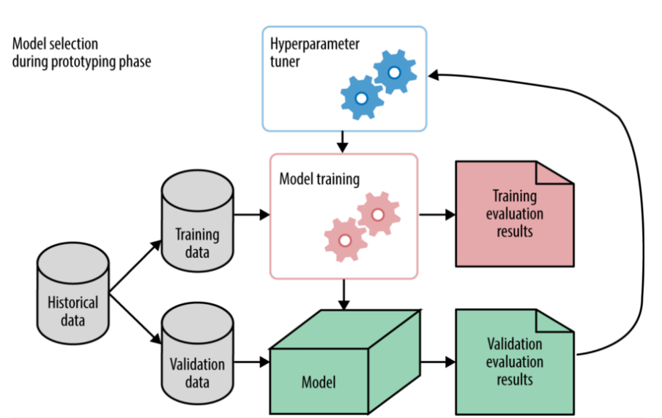

Next, interpreting data refers to the presentation of the data to a non-technical layman. The result is delivered to answer the business questions asked when the project first started, together with the actionable insights that are found through the data science process. At this stage, deployment of a data product is crucial. A data product, in general terms, is any tool or application that processes data and generates results. Businesses can use the results of such data analysis to obtain useful information like stock forecasting and customer segmentation and use these results to make smarter decisions.

GA2 Report Suggestions:

- Project background - Description of the Data Science Project (suitable for which organization, target users, potential benefits, etc)
- Project Objectives
- EDA
- Data Modelling
- Data Interpretation
- Plan for Reproducible Research
- Deployment of Data Product
- Insights and Conclusion
- References

Method & Submission for GA2:
- Submit the report on week 13 (before the lecture hour) in a softcopy form.
- Prepare a power Point slides for 7 minutes presentation. Utilize concepts and techniques learnt in Data Visualization and Storytelling in your presentation deck.
- Content should include basic explanation about each task and any related points that are suitable.
- A data product must be presented as part of your presentation
- You may include related diagrams, charts and any supporting material in your report.
- Format :
  - 1.5 spacing, Arial 11, maximum of 15 pages excluding cover page and attachment
- Your report should include cover page, with your group details (Name, matrix no, and topic).

Rubric GA2 (20%)
Bil | Items | Marks %
1 | Data Modelling and Interpretation | 30
2 | Plan for Reproducible Research | 10
3 | Data Product | 20
4 | Insights and Conclusion | 10
5 | Presentation (Data Storytelling and Visualization) and Q&A | 20
6 | Group Commitment | 10
 | Total | 100
Penalty for poor time management |  | -20

